Home Group Leaders Training – Handouts
Purpose and Group Leaders
July 7, 2019

New this year?
- Monthly meetings encouraged if …
- sermon discussion questions
- Chris and Kim visitation plan
- pray for …

How Home Groups support our Purpose:
- Means to practice ____________ (such as?), a key component of _____________
- Means to _____ ___ hurting, weak, discouraged, sinning saints, a key component of ______________
- Means to equip holy ones for the ______of discipleship
- Sermon ____________ is discipleship
- Loving ____________ encourages disciples to press on

Our Relational Goal in Picture Format – Michael
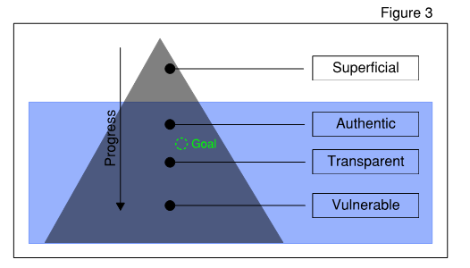

3 Roles of Home Group Host/Leaders:

- Hospitable ______
  - Comfortable, safe, warm place
  - Nothing says “Welcome” like your HOME!

- _______ Leader (Not Teacher or Preacher)
  - Draw out quiet ones
  - Redirect when needed
  - Let out some line; Reel in some line

- Listening ________

8 Traits of Effective Home Group Host/Leaders
- Practice the __________ (Worship, Walk, Work, Witness)
- ____________ (I Peter 4:7-11)
- Prepared: ____________ & ____________
- Committed
- Actually have a _____
- ______ don’t follow
- Sensitive to _______ needs
- W.A.L.K. w/ your group (Michael)
  - W_______
  - A___
  - L________
  - K_____

Home Group Leaders Training – Handouts
Groups and Meetings
July 28, 2019

5 ways to build commitment and regular attendance:
- Staff: “this is a commitment” during signups
- Strive for quality meetings & relational connections
- Have regular meetings on a consistent schedule
- Reach out to missing members
- Share responsibilities

7 Elements of an Effective Meeting:
- Food & Fellowship (esp. for new groups); aka intentional interaction (30-45 minutes)
- Group Discussion of the Word/Sermon (30-45 minutes)
- Accountability & Prayer – (30 minutes)
- Confidentiality
- Start/end on time (2-hour limit)
- Intentional yet flexible; predictable but not rigid
- Mutual ministry, not leader to group but one to another

How to have effective Prayer?
- Men with Men
- Pray requests instead of share requests
- Pick a prayer topic (marriage, parenting, jobs, witness, church needs)
- Popcorn prayer
- Share then pray. Share then pray.
- Pray w/ one another between meetings (phone, text, email, lunches)

What Works Well?
- Themed pot-luck (possibilities are endless)
- Icebreaker games if group of strangers
- Use 1 or 2 good questions:
  - What’s on your mind?
  - What are you thankful for?
  - How did today’s sermon speak to you?
  - What challenge are you facing and how coping?
- Share hosting for summer sessions
- Open ended questions

What Hasn’t Worked Well?
- Big group prayer if the group isn’t close
- Kids running wild
- No plan, direction or leadership; no content
- Inconsistent meetings, times and places
- For some groups, trying to meet in the summer

8 Pitfalls to Avoid:
- Unbalanced w/ time. Correction? Big 3.
- Over-talkative Tom or Silent Suzy. Solution?
- The Leader Lectures. Solution?
- Poorly worded questions. Examples?
- Lose track of time and go on and on and on and on
- Time gets wasted
- Fail to beg God for help beforehand or thank after
- Allowing false doctrine w/o gentle correction

How will we add members during the year?
Overseeing elder (Chris) assigns new comers to groups in coordination with group leaders OR you add on your own as leader/group until at max capacity.

How are new groups formed each year?
- Current leaders ID an Apprentice … Discern
- Share Leadership w/ Apprentice … Delegate
- Evaluate Leadership of Apprentice … Develop
- Recommended Apprentice for training;
Apprentice becomes Group Leader Deploy

Sign Up Logistics:
- Sign-up sheets to Foyer August 4 – Sept.1 for groups needing them (Some already full).
- Leaders decide their max #. Suggestion: min of 8 and max of 14 (not counting host couple).
- Sign-up sheets are removed as they fill up, scanned and emailed to the leaders.

Begin meeting in September!!

May the Lord reveal Himself in, to and thru your group!

