#11 – Is Psychology Okay?

Modern psychology (study of human behavior) and its cousin psychiatry (study of mental disorders) are disciplines that came into prominence in early 20th century. Psychology is not a scientific discipline. It is a worldview about the nature of humanity and how we make sense of human behavior. Psychiatry is related to psychology but largely focuses on physiological (namely, bio-chemical) sources for mental disorders. Psychology grew out of anti-theistic (humanistic) worldview. It is a secular discipline that tries to understand human behavior apart from God and religion.

Most iterations of secular psychology try to be neutral or values-free. The goal of most secular mental health counseling is to produce well-adjusted happy people based on whatever values are important to particular counselees. It places the self at the center of reality (i.e., it is human-centered instead of God-centered). Personal happiness, in whatever way people define that for themselves, is to be pursued at all costs. We see this in mantras like “follow your heart”; “be all you can be”; “you deserve a break today”; “look out for number one”, etc. But this values-free thinking ends up embracing moral relativism, which always leads to nihilism. Nihilism means there is no objective meaning or purpose to life, only what meaning you create for yourself.

I. Four Horseman of the Psychological Apocalypse
Sigmund Freud. Freud is the father of modern psychology. He was an atheist. He did not believe humans had immaterial souls. This life is all there is. No after-life, no ultimately accountability to anyone outside ourselves. Furthermore, Freud saw humans as irredeemable. He was influenced by Nietzsche’s nihilism.

Carl Jung. Freud emphasized the individual’s unconscious influences in terms of neuroses. Jung emphasized the collective unconscious; all human beings share a hidden history symbolized by different archetypes. He was heavily influence by the occult.

B. F. Skinner. Behaviorist. He rejected the idea of an immaterial soul, and like Freud, believed humans have no ultimate meaning or purpose. The goal of therapy is to manipulate emotional or physical circumstances so as to eliminate pain and maximize pleasure.

Carl Rogers. Rogers was more optimistic than Freud or Skinner. He saw humans as basically good and therefore perfectible. However, Rogers (like Freud) did not believe in offering counsel, only trying to ask clarifying questions and making summarizing statements to help people identify their own problems (self-therapy). This is a sort of a “I’m here to help you help yourself.” Rogers also did not make moral judgments (e.g., for or against Christianity). The counselor must be neutral (i.e. pretend to be neutral). People are free to be whatever they want to be, and psychotherapists are to encourage patients to embrace their own meaning or identity (e.g. homosexual, transgender, etc.).

Other influential psychological thinkers include Abraham Maslow and William James.

Maslow’s Heirachy of Needs
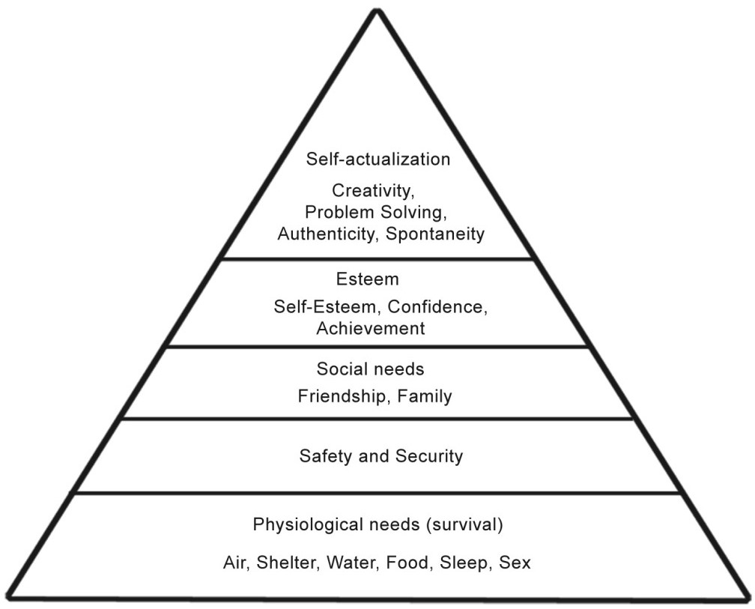

II. Modern Psychology and Christianity
In the 1950’s and 60’s secular psychology made extensive inroads into evangelical Christianity after already having been adopted wholesale by liberal Christianity in the early to mid-20th century. Evangelicals began embracing what is known as the Integrationist [syncretistic] model of Christian Counseling. One Christian counselor put it like this: Think of the dashboard control for the HVAC system in a car. The cool side represents secular insights into human behavior. The hot side represent Biblical insights. We must mix them together for most comfortable setting.

Throughout Christian history there has always been a concern for soul-care, that is, addressing the problems people face, particularly Christians. The Puritans were experts at soul-care using only the Bible, but the advent of modern secularism caused this approach to be compromised. Subsequently, in modern Christianity, when people suffer serious ‘psychological’ problems they have consistently turned to the professional mental health ‘professionals’; psychologists, psychiatrists, therapists, and counselors instead of pastors. As secular psychology has become the norm, the function of soul-care that pastors historical carried has been reduced to a narrow set of religious issues (e.g., how to be saved). This devaluing of pastoral care coincides with the broader drifting of the evangelical movement.

Christian Smith has accurately characterized modern mainstream evangelical belief as “moralistic therapeutic deism.” He characterizes the beliefs of this quasi-religious outlook at follows:

a. A God who created and orders the world and watches over human life on earth.
b. God wants people to be good, nice, and fair to each other, as taught in the Bible and by most world religions.
c. The central goal of life is to be happy and to feel good about oneself [the primary goal of modern psychological therapy].
d. God does not need to be particularly involved in one’s life except when He is needed to resolve a problem [with the help of psychological therapy].
e. Good people go to heaven when they die.

The good news is over the course of the last 20-25 years there has been an increasing recovery of the pastoral care that marked the ministry of the Puritans in what is called the “Biblical Counseling” movements represented by organizations like the Christian Counseling & Education Foundation (CCEF) and the Association of Certified Biblical Counselors (ACBC). The goal of Biblical counseling can be easily summed up in the desire to help Christian cultivate the fruit of spirit (Gal. 5:22-23) in the pursuit of godly Christ-likeness (sanctification) why mortifying the deeds of the flesh (Rom. 8:13). This means that the primary problem humans face is not a lack of happiness but the depravity of sin.

However, the problem of sin is no longer a relevant category in secularized society. Sigmund Freud popularized idea that people are not to blame for their problems. Blame is placed on parents, childhood trauma, the environment, etc. People are encouraged to think of themselves as victims. We avoid personal responsibility. In this regard, psychology is easier to use in dealing with problems because it is easier to coddle people than to confront them. This does not mean that we are not victims of unfortunate circumstances or the sins of other, but we do bear responsibility for how we respond to these circumstances. In either case, most human problems are sin problems.

Furthermore, much of modern psychological counseling is designed to minimize suffering and increase happiness. We naturally want to find ways to minimize suffering when in fact God may be using our suffering as a means of sanctifying us (Phil. 3:10-11; Rom. 8:16-17; 1 Pet. 4:12-13; Col. 1:24; 2 Cor. 12:9-10). The overall goal in Biblical Counseling is not to relieve suffering per se, but to produce godly mature Christians. It is true that Christ sought to relieve suffering in his ministry, and we should be concerned to do the same. But it should never be an end in itself.

III. What is Biblical Counseling?
Biblical Counseling is simply the application of Biblical truth, wisdom, principles, and moral commands to human problems so that people change—that is, they are engaged in the morally transforming work of sanctification, growing in godliness, the fruits of the Spirit, and Christ-likeness. Good Biblical Counselors are good Biblical theologians and interpreters of Scripture. They are careful listeners, who ask good questions to get to the root of problems people face. They are wise in their application of Biblical truths to human problems.

1 Thessalonians 5:14 provides a good metric for what Biblical Counselors do when counseling a troubled Christian.
“And we urge you, brethren, Especially those who are spiritual (Gal 6:1; cf. Eph 4:25)
(1) admonish the unruly, Confront personal responsibility for sin.
(2) encourage the fainthearted, Relieve spiritual suffering due to trials & tribulations.
(3) help the weak, Strengthen those who are immature in their faith.
be patient with all men.” Recognize change can take time.

Humans are composed of body and soul. The medical profession is necessary for body care. Biblical Counseling is necessary for soul care. But sometimes body and soul interact (Psa. 32:3-4; 2 Cor. 4:16). Can medication be used if body and soul are intertwined in spiritual problems? Yes, but only when used cautiously and always in conjunction with providing Biblical counsel to address issues of the soul (heart, mind, and will).

Principles of Biblical Counseling (David Powlison)
1) God is at the Center of Counseling.
2) Centrality of Scripture. The Bible is necessary, authoritative, comprehensive, timelessly relevant, supremely wise, and sufficient for all our fundamental spiritual needs as human beings.
3) Sin is the Problem. The primary problem Christians face is sin. The motives, thoughts, words, and actions drive who we are and what we do. Counseling addresses wrong behavior, distorted thinking, and provides a reorientation to right thinking and behavior. Counseling is not about unmet psychological needs, rooting out demons of sin, poor socialization, inborn temperament/ personality, healing damaged emotions, genetic predisposition, or anything that detracts from our basic rebellion against God. Furthermore, we face problems dealing with the sin of others perpetrated against us as well as the pain caused by unfortunate occurrences in our circumstances. Thus, some issues require confrontation, others require encouragement, and others require help for those who are weak (1 Thess. 5:14).
4) The Gospel is the answer. Forgiveness of sin and the power to change into conformity to Christ are the greatest needs of people. Counseling via the grace of the gospel addresses the guilt, shame, power, deception, and misery of sin.
5) Change is progressive sanctification. Change is not instantaneous, but progresses throughout the Christian life.
6) Situational difficulties are not the cause of problems. Situational difficulties are merely the occasions that reveal our hearts and the idols we uphold. Situations are not ignored, but they are not the root of the problem.
7) Counseling is Pastoral Care. Counseling is merely the application of the preaching, teaching, and principles of Scripture in the context of believers engaged in the life of the church via prayer, discipleship, discipline, use of gits, worship, etc. Counseling is a ministry of the church, by the church, and for the church.

IV. Some Popular Psychological Categories
These are areas of thinking that have had a profound influence on modern evangelicalism. Notice that at the root of each of these popular notions is an undue focus upon one’s self at the expense of God and others. Pride is the root of all sin. All of life is lived either in pursuit of God or in retreat from Him. People, first and foremost, need to think of themselves (and must be treated) in terms of their relationship with God (2 Cor. 5:16-19), otherwise our perspective of who we truly are will be distorted at best, and destructive at worst.

- Low Self-worth/ self-esteem
Robert Schuller popularized the idea that sin is not transgression of God’s law but thinking more
lowly of yourself than you ought. Joel Osteen has also capitalized on this idea. Robert Schuller: “I don’t think anything has been done in the name of Christ and under the banner of Christianity that has proven more destructive to human personality and, hence, counterproductive to the evangelicalism enterprise, than the often crude, uncouth, and unchristian strategy of attempting to make people aware of their lost and sinful condition.” David Seamans in Healing for Damaged Emotions says low self-esteem is “Satan’s deadliest weapon.”

While all human beings are created in the image of God and therefore, have a unique dignity that must be respected, sin has shattered this disposition such that our primary problem is exalting ourselves and thinking more highly of ourselves than we ought. We are fundamentally self-centered, conceited, and unconcerned about others (see Phil. 2:3-4). We have placed ourselves at the center of our universe instead of God and others.

- Learn to Love Yourself
The issue of self-love and self-esteem are twin brothers. Paul says in the last days men will be “lovers of self” (2 Tim. 3:1-4). The idea of self-love is axiomatic. There is no such thing as self-hate. Notice the two great commands: "You shall love the Lord your God with all your heart and with all your soul and with all your mind…and…You shall love your neighbor as yourself” (Matt. 22:37, 39). There is never a command in Scripture to love ourselves; we already do that naturally. The root of sin is pride. Subsequently, when someone says, “I hate myself” it is often merely code for “I have failed.” My pride is hurt. I did not meet the expectations of myself or others so that I could look good in their eyes or my own (or obviously both). However, the only eyes that ultimately, we need approval from is God’s. Through Christ we gain his approval.

Everything we do is done in the service of self-interest. Blaise Pascal said: “All men seek happiness [i.e., their own well-being]. This is without exception. Whatever different means they employ, they all tend to this end.… The will never takes the least step but to this object. This is the motive of every action of every man, even of those who hang themselves.” This is not always bad. Salvation and devotion to Christ is in our self-interest. The difference is when we move ourselves from the center and put Christ there instead, then what is truly in our best interest (i.e., salvation, peace, joy, hope, etc.) will becomes ours.

- Forgiving Yourself
Again, there is not a single command in the Bible to forgive yourself. God forgives sinners and forgiven sinners are called to forgive one another.
God > sinners
forgiven sinners >< forgiven sinners
The idea of forgiving one’s self stems from a complete disregard of God as being at the center of our self-perception and existence. We live for him not ourselves. Forgiveness is necessary when a moral law (standard) has been violated. God is the not only the ultimate moral standard, but also the one who is ultimately offended when we violate his moral laws (standards). Therefore, only God can pardon sin and remove our guilt and shame.

This means we are not the standard for own actions, therefore we do not violate some self-imposed law for ourselves that requires we forgive ourselves. This is an entirely self-referential mindset in which the orientation of being rightly related to God is missing. We belong to God. We are accountable to Him. We owe our allegiance to Him. He is to be our all-in-all. Furthermore, when Christians bemoan the fact that they are guilty of some egregious misdeed (e.g., abortion) and say “I can never forgive myself” they fail to recognize that if God has forgiven them, then they are free of their guilt and shame. In our minds, our sin and guilt is greater than God’s grace. We must come to grips with the fact that God’s grace is infinitely rich and powerful and able to forgive and cleanse one from the deepest and most egregious sins.

V. Mental Illness
The secular Bible when it comes to the concept of mental illness is The Diagnostic and Statistical Manual for Mental Disorders (DSM – DSM-1 came out in 1952, DSM-5 in 2013). Before the 20th century, very few mental disorders were identified as such (except for things like schizophrenia (bi-polar), paranoia, melancholia (depression), etc). While the DSM makes many accurate observations about human problems, it fails miserably at interpretation (causes) and treatment (therapies/ interventions, etc.). There are no medical tests for psychiatric and mental disorders like there are for diabetes or cancer or celiac disease (unless intoxicating substances are involved such as illicit drugs and alcohol). Mental behaviors (disorders) are largely based on symptoms of self-reporting and the mental health professional’s assessment (usually based on the DSM).

Some behavioral issues are the result of clearly defined physiological problems that are medically verifiable (e.g., autism). Others are simply descriptive with no medical tests to verify. Subsequently, it is not clear that any physiological connection to a so-called mental illness can be made. This means it is probably strictly an immaterial “soul” issue, meaning it is connected to one’s (1) immaterial personality (which is itself a subjective description); (2) a spiritual and/or moral problem. However, the physiological (body) and immaterial (soul) are often connected (see Ps. 32:3-4). A couple of examples of so-called disorders that have no medically verifiable (testable) cause are:
OCD (Obsessive Compulsive Disorder). Personality?
GAD (General Anxiety Disorder). Spiritual sin or immaturity? Read Philippians 4:6-7, 8-9.
PTSD (Post-traumatic stress disorder). Traumatic experience.

There are two views of mental illness in secular psychology:
(1) Psychodynamic – This means people suffer from neurosis (psychological trauma) on a spectrum between well (sane) and unwell (insane). The source of problems lies in the person’s mind or unconscious (Freud’s influence here). Psychotherapy is used to address mental illness and looks for causes in the unconscious mind, memories, childhood trauma, etc.
(2) Bio-chemical – This means mental disorders are caused by malfunctioning neurotransmitters. This view coincided with the introduction of the first antidepressants in 1950’s. By the time the DSM-3 was published (1980), the biochemical view triumphed. However, the DSM is largely confined to the descriptive and does not focus on precise causes. For example, one may see symptoms of anger (red face, teeth clenched, stomping feet, yelling), but this does not tell you why the person is angry. Thus, psychiatric diagnoses are descriptive not explanatory. They tell you what but not why. This coincides with the materialist worldview that reduces human experience, behavior, etc. to biology (i.e., brain chemistry). Even morality is reduced to bio-chemical and physiological explanations. There is no belief in an immaterial soul.

The triumph of the bio-chemical view of mental illness has led to an explosion in psychotropic medications as the primary treatment for so-called mental disorders. It is not a multi-billion dollar industry that sees no sign of abating. Psychotropic medications do affect the body, but we don’t know exactly how or why. It is a mind field of confusion, unsubstantiated claims, and no clear understanding of what these medications really do.

For example, overall, 35% of patients who are given placebos for depression improve after taking them. This indicates how powerful belief and perception are. In some cases, 70% improve after taking medications, but even the medications themselves can have a placebo effect and there is no way to determine that. It is difficult to determine if therapy (counseling) is more effective because you have too many different counseling methodologies to evaluate. Antidepressants seem to work some of the time for some people, but this does not address underlying issues. A person’s mood may improve from antidepressants but they have not addressed potential factors that led to depression in the first place.

In another example, 9% of US children diagnosed with ADHD (Attention Deficient Hyperactivity Disorder) take psychotropic medication (such as Ritalin). However, only 0.5% of French children diagnosed with ADHD take psychotropic medications. The symptoms of so-called ADHD in France are largely addressed by social and relational interventions.

VI. Chemical Imbalance and Depression
The idea behind anti-depressants is that there is a supposed chemical imbalance in the brains of chronically depressed people. Namely, they supposedly have low levels of serotonin. But the latest research confirms what many have already been saying that there is no scientific correlation between serotonin levels and depression. In the last 15 to 20 years new research has questioned the chemical imbalance hypothesis.

Daniel Carlat, says in a recent NPR interview:
We don’t know how the medications actually work in the brain…. I’ll often say something like the way Zoloft works, is, it increases the level of serotonin in your brain (or synapses, neurons) and, presumably, the reason you’re depressed or anxious is that you have some sort of a deficiency. And I say that [chuckles] not because I really believe it, because I know the evidence really isn’t there for us to understand the mechanism—I think I say that because patients want to know something. And they want to know that we as physicians have some basic understanding of what we’re doing when we’re prescribing medications. They certainly don’t want to know that a psychiatrist essentially has no idea how these medications work (Qtd. in Lacasse and Leo).

Note this advertisement for Zoloft (antidepressant similar to Prozac):

Social anxiety can be overwhelming. You might shake, sweat, or feel panicky. You may feel embarrassed when you are in a group. You may worry that you are being judged. You just feel so isolated. These are some signs of social anxiety disorder. It is a real medical condition [?] that can get in the way of your daily life. The cause is unknown [?]. But it may happen [?] when natural chemicals between the brain’s nerve cells are out of balance. Prescription Zoloft works to correct this imbalance. [Brackets and italics mine]

Note that if you say I have “social anxiety disorder” it does not carry the same stigma as saying I struggle with anxiety in social situations (as if you have any control or responsibility for your reaction). You can blame it on a medical condition (brain disease) that takes away any part your thinking might contribute to the anxiety. This is part of the modern mental health deception because there is no medical test for social anxiety disorder.

A new exhaustive review of the evidence, the first of its kind, was released on July 19, 2022, in the journal Molecular Psychiatry by University College London Psychiatry Professor Joanna Moncrieff and a team of five other top European researchers entitled: “The Serotonin Theory of Depression: A Systematic Umbrella Review of the Evidence.” They found “there is no evidence of a connection between reduced serotonin levels or activity and depression.” They state that “85-90 percent of the public believes that depression is caused by low serotonin or a chemical imbalance.” See “A Decisive Blow to Blow to the Serotonin Hypothesis of Depression” in Resources.

Sometimes the DSM has a tendency to abnormalize the normal. For example, some people who are introverts (quiet, shy types) are normal people with certain personality traits that are neither good nor bad. Yet, often our culture puts forth the extrovert (outgoing) as the model of normalcy. If you are an extrovert, then you are normal. If you are an introvert, then you are abnormal (weird). However, note, an abnormal (by societal standards) person may be living faithfully to Christ while a normal person may be living a life rebellion against God.

DSM also characterizes disorders as a medical conditions that Scripture defines as sin. For example, the DSM labels all sorts of sexual perversions as mental disorders that are plainly sin. Also consider pyromania (unable to resist the urge to set things on fire), kleptomania (unable to resist the urge to steal). The term “Alcoholism” is used in such a way as to be perceived as medical condition over which someone has no control. But the Bible calls this drunkenness, and it is clearly a sin (1 Cor. 5:11; 6:10).

Resources:
Books:
Richard Ganz, PsychoBabble: The Failure of Modern Psychology and the Biblical Alternative
Heath Lambert, A Theology of Biblical Counseling
Paul David Tripp, Instruments in the Redeemer’s Hands: People in Need of Change Helping People in
Need of Change
Michael R. Emlet, Descriptions and Prescriptions: A Biblical Perspective on Psychiatric Diagnoses &
Medications.
Websites:
Association of Certified Biblical Counselors: www.biblicalcounseling.com
Christian Counseling & Education Foundation: www.ccef.org
Articles:
“A Decisive Blow to Blow to the Serotonin Hypothesis of Depression” www.psychologytoday.com/us/blog/side-effects/202207/decisive-blow-the-serotonin-hypothesis-depression

